**Practical No. 2**

**Q. Study of Android Life Cycle and its Phases.**

**1. Designing UI**

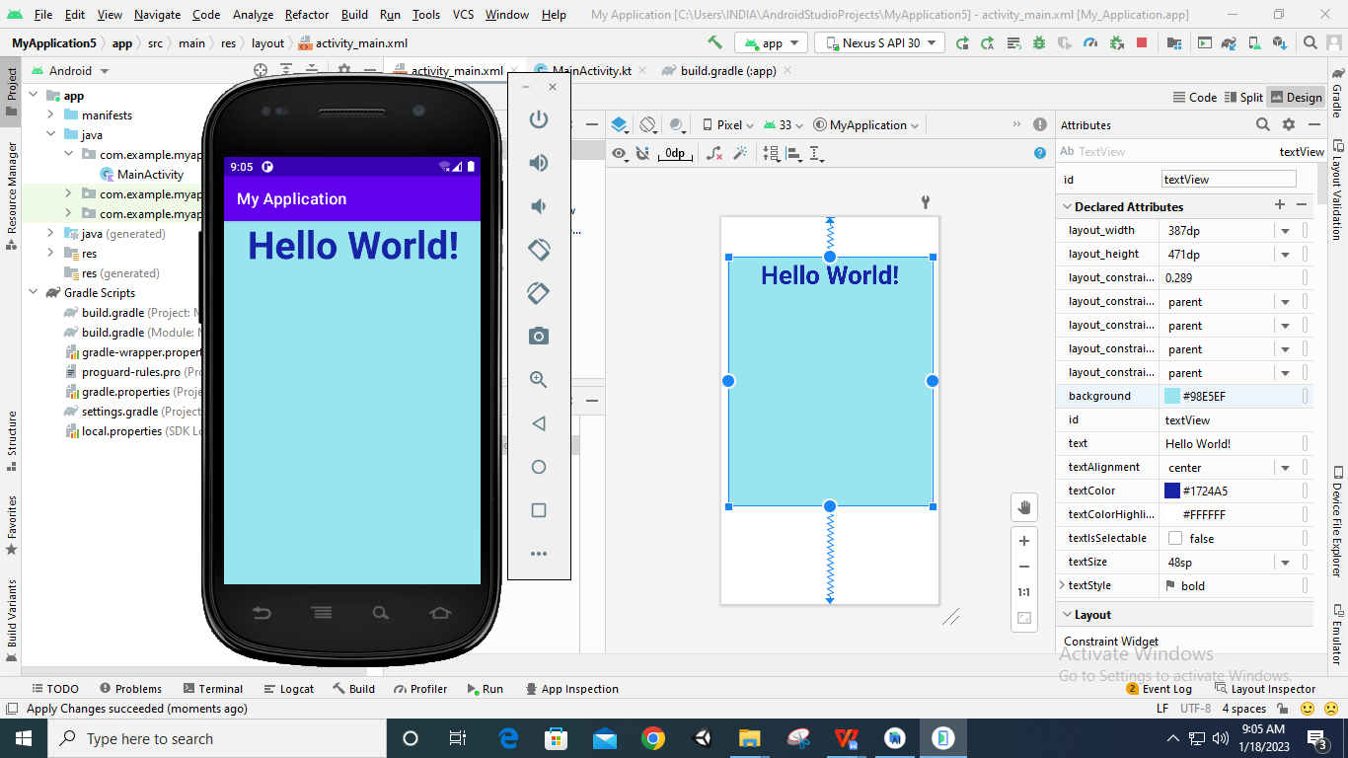

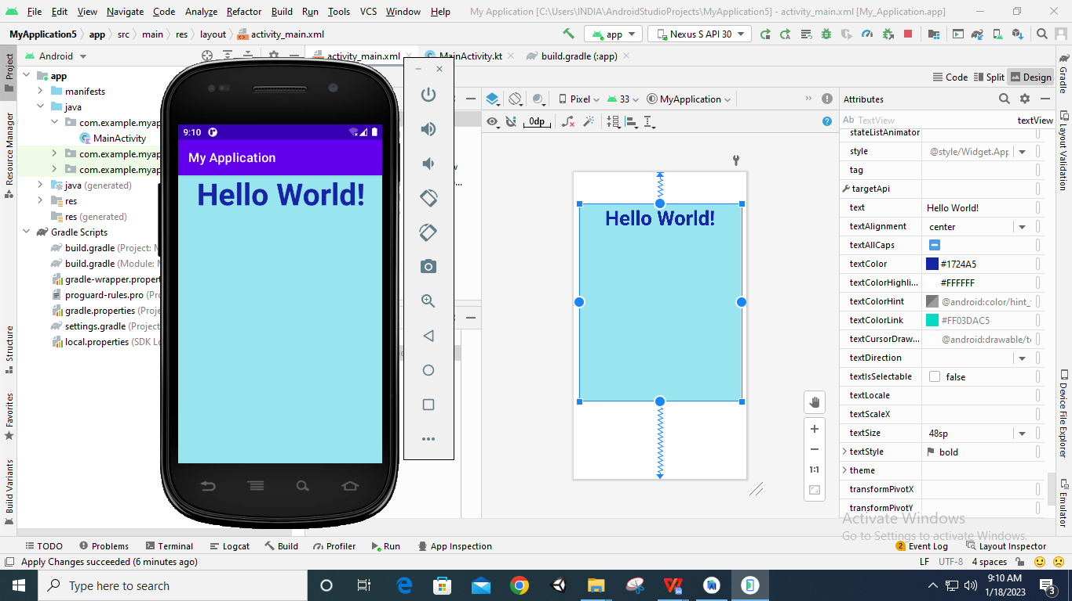

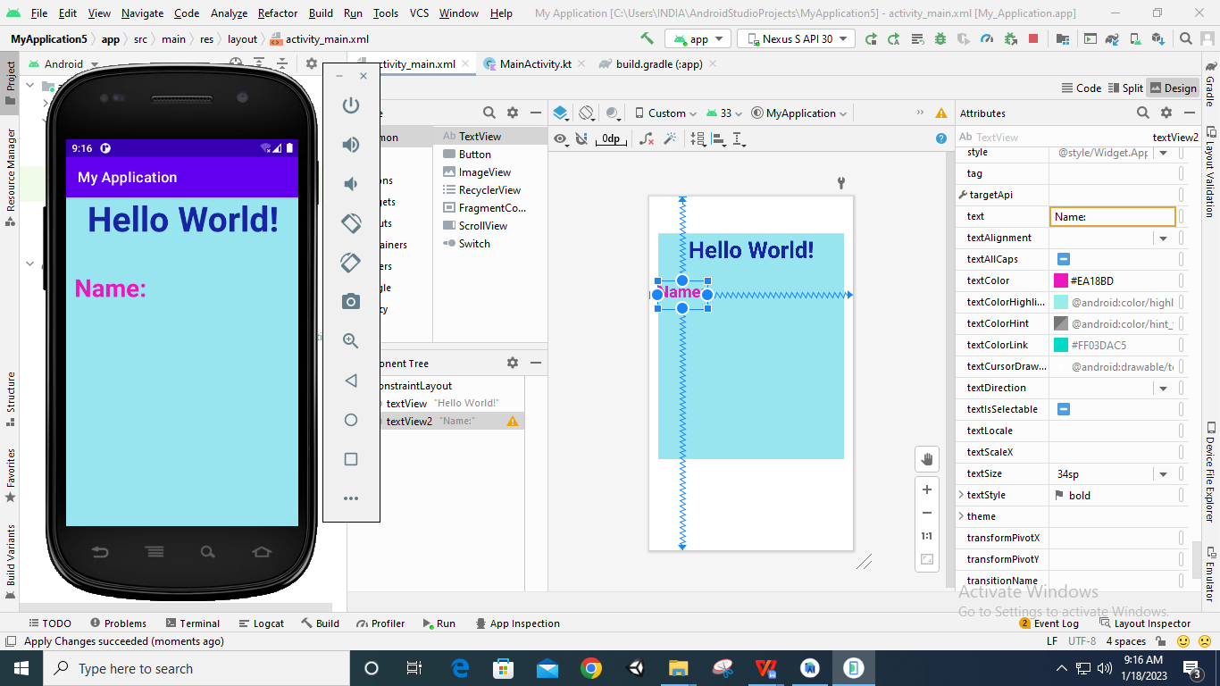

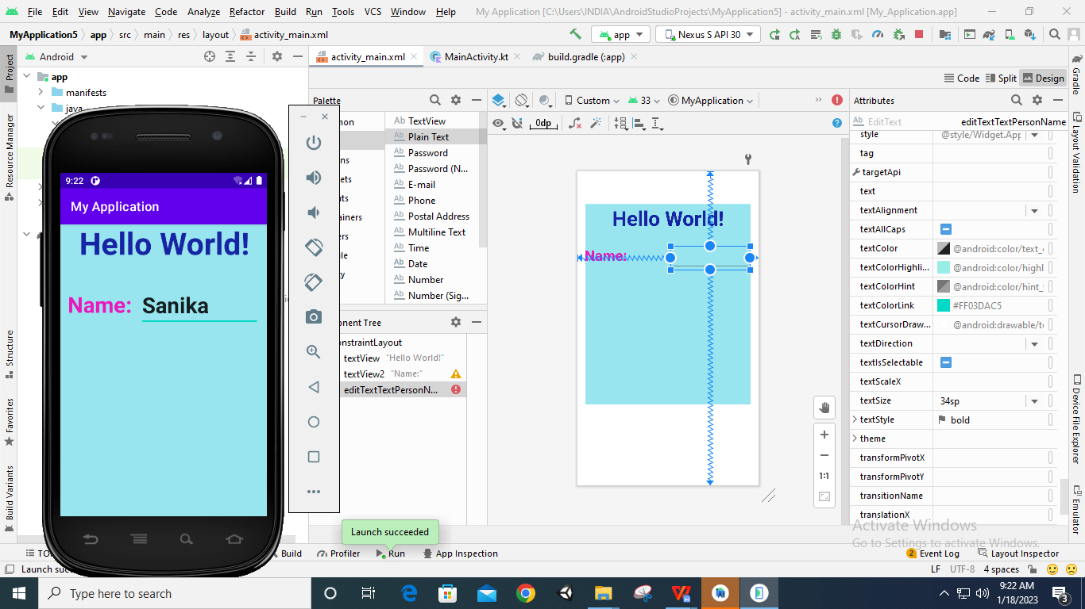

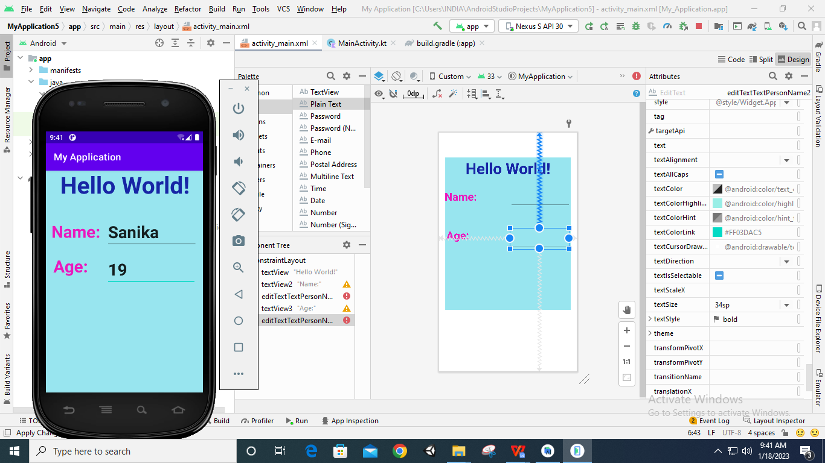

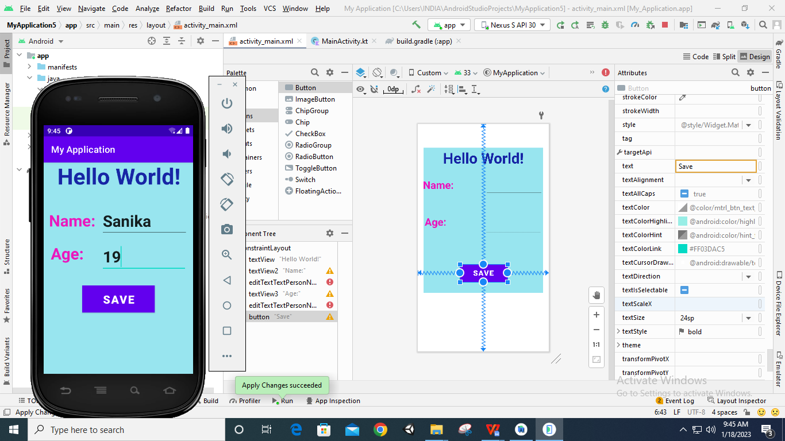

1. **Code:**

**package** com.example.myapplication  
  
**import** androidx.appcompat.app.AppCompatActivity  
**import** android.os.Bundle  
**import** android.util.Log

**class** MainActivity : AppCompatActivity() {  
 **var tag**=**"Activity_Event"  
 override fun** onCreate(savedInstanceState: Bundle?) {  
 **super**.onCreate(savedInstanceState)  
 setContentView(R.layout.*activity_main*)  
 }  
 **override fun** onStart(){  
 **super**.onStart()  
 Log.d(**tag**,**"..onStart() Occurred.."**)  
 }  
 **override fun** onResume(){  
 **super**.onResume()  
 Log.d(**tag**,**"..onResume() Occurred.."**)  
 }  
 **override fun** onPause(){  
 **super**.onPause()  
 Log.d(**tag**,**"..onPause() Occurred.."**)  
 }  
 **override fun** onStop(){  
 **super**.onStop()  
 Log.d(**tag**,**"..onStop() Occurred.."**)  
 }

**override fun** onRestart(){  
 **super**.onRestart()  
 Log.d(**tag**,**"..onRestart() Occurred.."**)  
 }

**override fun** onDestroy(){  
 **super**.onDestroy()  
 Log.d(**tag**,**"..onDestroy() Occurred.."**)  
 }  
}

1. **Output:**

